ARTIFICIAL INTELLIGENCE LAB ASSIGNMENT
Title
Development of a Student Attendance Chatbot Using Google Dialogflow

Question 1: Problem Analysis and Agent Design
Problem Analysis
In educational institutions, students frequently ask questions regarding their attendance percentage and attendance records. Answering these queries manually requires faculty members or administrative staff to spend considerable time responding to each student individually. This process can be time-consuming and inefficient.
To solve this problem, an Artificial Intelligence (AI)-based conversational agent can be developed using Google Dialogflow. The chatbot automatically understands student queries written in natural language and provides instant responses about attendance information.

How Artificial Intelligence Solves the Problem
Artificial Intelligence uses Natural Language Processing (NLP) to understand user questions, identify the user's intent, extract important information such as the subject name, and generate an appropriate response.
For example:
User: "What's my attendance in DBMS?"
The chatbot:
- Understands that the user is asking about attendance.
- Identifies DBMS as the subject.
- Generates the response:
"Your attendance in DBMS is 92%."
Thus, AI enables quick, accurate, and automated responses.

Agent Design
Agent Name
UniAssist Student Support Bot
Objective
To provide students with quick and accurate attendance information through a conversational chatbot.
Target Users
- Students
- Faculty members
Environment
- Google Dialogflow Essentials
- College Website
- Mobile Application
Inputs
The chatbot accepts natural language queries such as:
- What's my attendance in DBMS?
- Attendance in AI
- Show my attendance record
- Attendance percentage please
Outputs
The chatbot returns attendance-related responses.
Example:
Your attendance in DBMS is 92%.
Performance Measures
The chatbot performance is measured using:
- Response Accuracy
- Fast Response Time
- Correct Intent Recognition
- Correct Entity Extraction
- User Satisfaction

AI Components Used
AI Component | Purpose
Natural Language Processing (NLP) | Understand user queries
Intent Recognition | Identify attendance-related requests
Entity Recognition | Detect subject names such as DBMS, AI, Networks
Dialog Management | Generate appropriate responses

Question 2: Dialogflow Agent Development
Agent Name
UniAssist Student Support Bot

Intent Created
Attendance.Query
The Attendance.Query intent is designed to answer student attendance-related questions.

Training Phrases
The chatbot was trained using the following example phrases:
- What's my attendance in DBMS?
- Can you tell me my attendance percentage?
- How many classes have I missed in Networks?
- Attendance percentage please
- Show my attendance record
- Is my attendance okay for AI course?
- Missed how many classes in DBMS?
The subject names DBMS, AI, and Networks were tagged using the custom entity @subject.
Screenshot 1: Attendance.Query Training Phrases 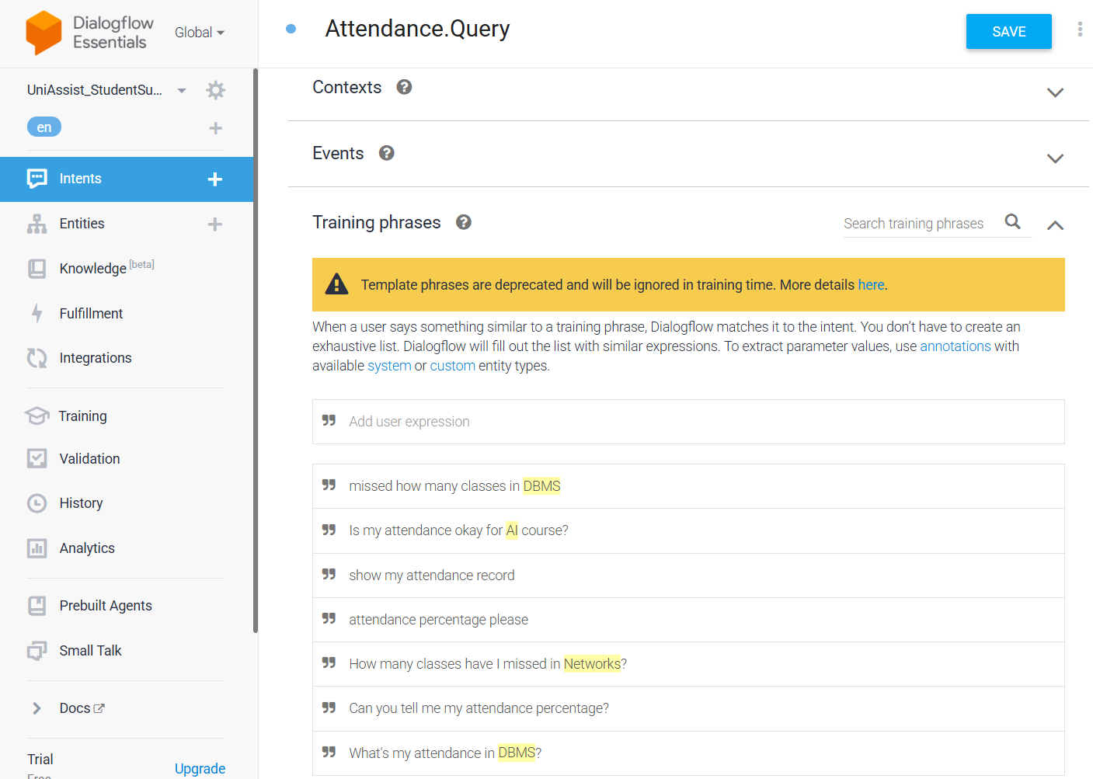
Entity
Custom Entity:
@subject
Entity values:
- DBMS
- AI
- Networks
The entity extracts the subject name mentioned by the student.

Action and Parameters
Action Name:
attendance.check
Parameter Configuration:
Parameter | Entity | Value
subject | @subject | $subject
The parameter captures the subject name entered by the user.

Screenshot 2: Action and Parameters
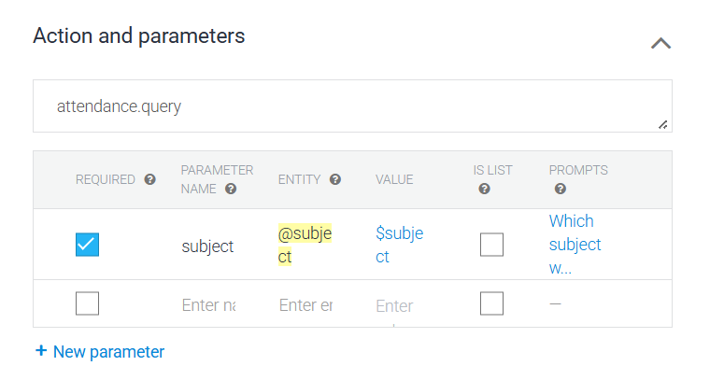

Responses
The chatbot provides dynamic responses using the extracted entity.
Example Response:
Your attendance in $subject is 92%.
The variable $subject is automatically replaced with the subject entered by the user.
Example:
User:
What's my attendance in DBMS?
Bot:
Your attendance in DBMS is 92%.

Screenshot 3: Responses
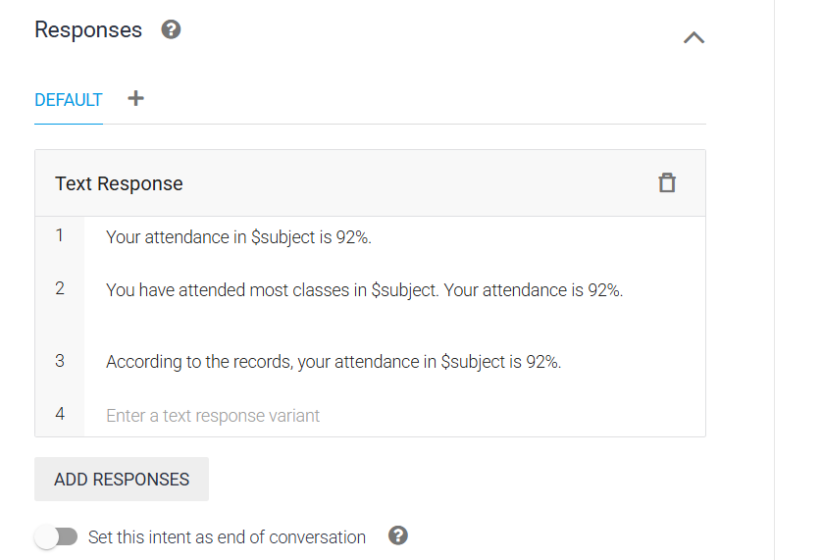

Working of Dialogflow
- User enters a query.
- Dialogflow processes the text.
- Intent is recognized.
- Subject entity is extracted.
- Appropriate response is generated.
- Response is displayed to the user.

Question 3: Problem Formulation and Decision Flow
Initial State
The chatbot waits for a student's query
Goal State
The chatbot successfully answers the student's attendance-related question.
Possible Actions
- Ask attendance percentage.
- Ask attendance in a subject.
- Ask missed classes.
- Request attendance record.
Goal Completion
The goal is achieved when the chatbot correctly understands the user's question and provides the requested attendance information.
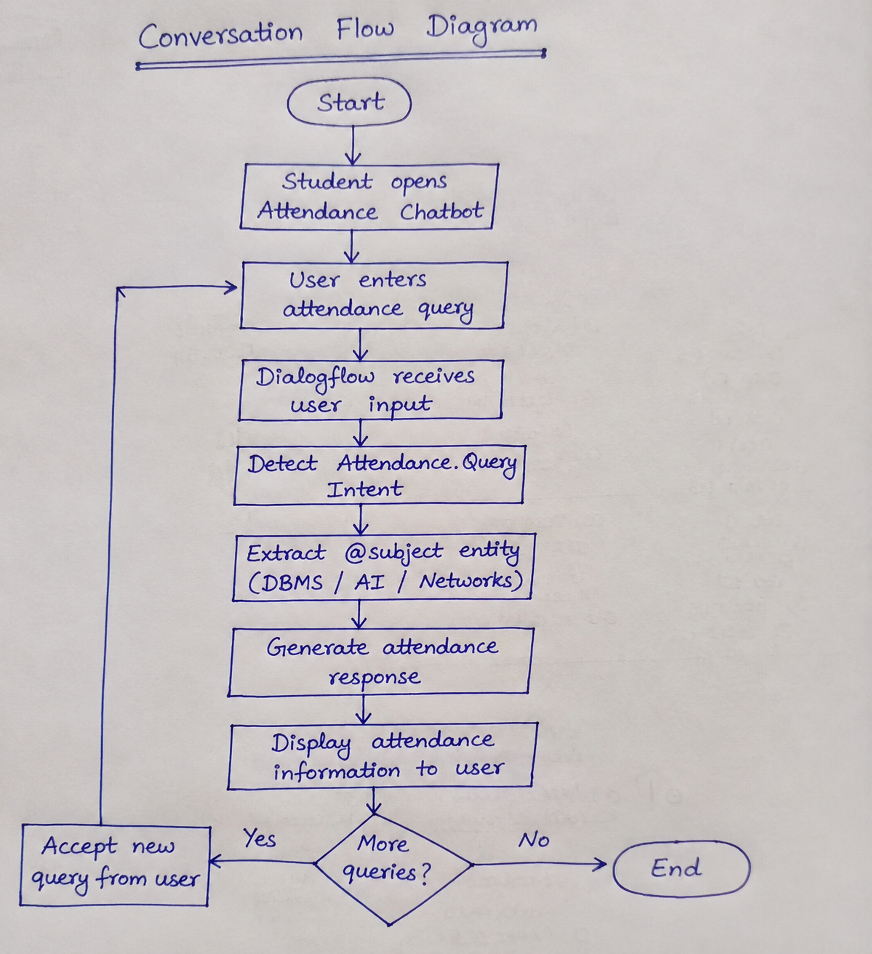
Question 4: Search Strategy Application
Search Strategy
Artificial Intelligence uses search strategies to determine the most appropriate solution. In conversational agents, search strategies help identify the correct intent for a user's query.
This chatbot uses a heuristic-based search because Dialogflow internally assigns confidence scores to each intent and selects the best matching one.

Example
User Query:
What's my attendance in DBMS?
The chatbot compares the query with all available intents.
Intent | Confidence Score
Attendance.Query | 98%
Fee Query | 20%
Hostel Query | 15%
Placement Query | 10%
Since Attendance.Query has the highest confidence score, the chatbot selects it and extracts DBMS as the @subject entity.

Why Heuristic Search?
- Faster intent selection.
- High accuracy.
- Efficient response generation.
- Better user experience.

Question 5: Testing and Evaluation
Testing
The chatbot was tested with different user queries to verify its accuracy and functionality.
Test Case | User Query | Expected Response | Result
1 | What's my attendance in DBMS? | Your attendance in DBMS is 92%. | Pass
2 | Attendance in AI | Your attendance in AI is 92%. | Pass
3 | Attendance in Networks | Your attendance in Networks is 92%. | Pass
4 | Show my attendance record | Attendance information displayed | Pass
5 | Attendance percentage please | Attendance percentage displayed | Pass

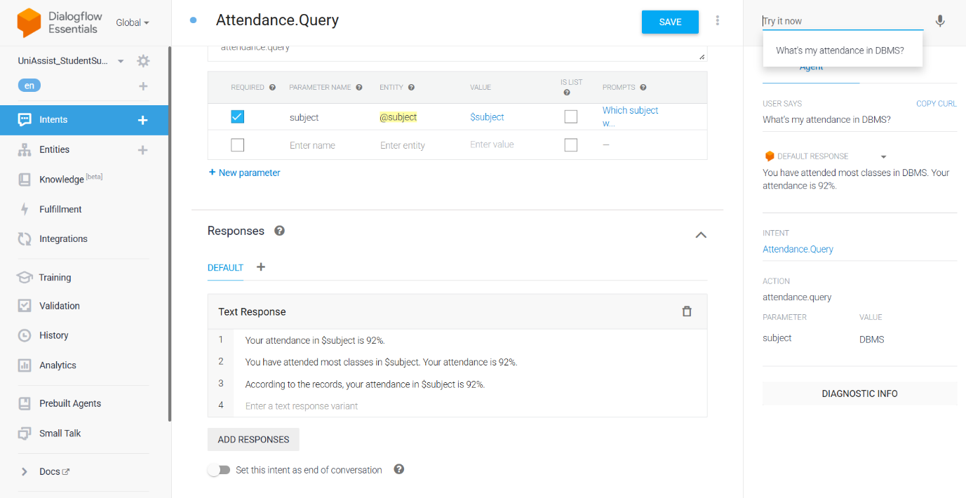

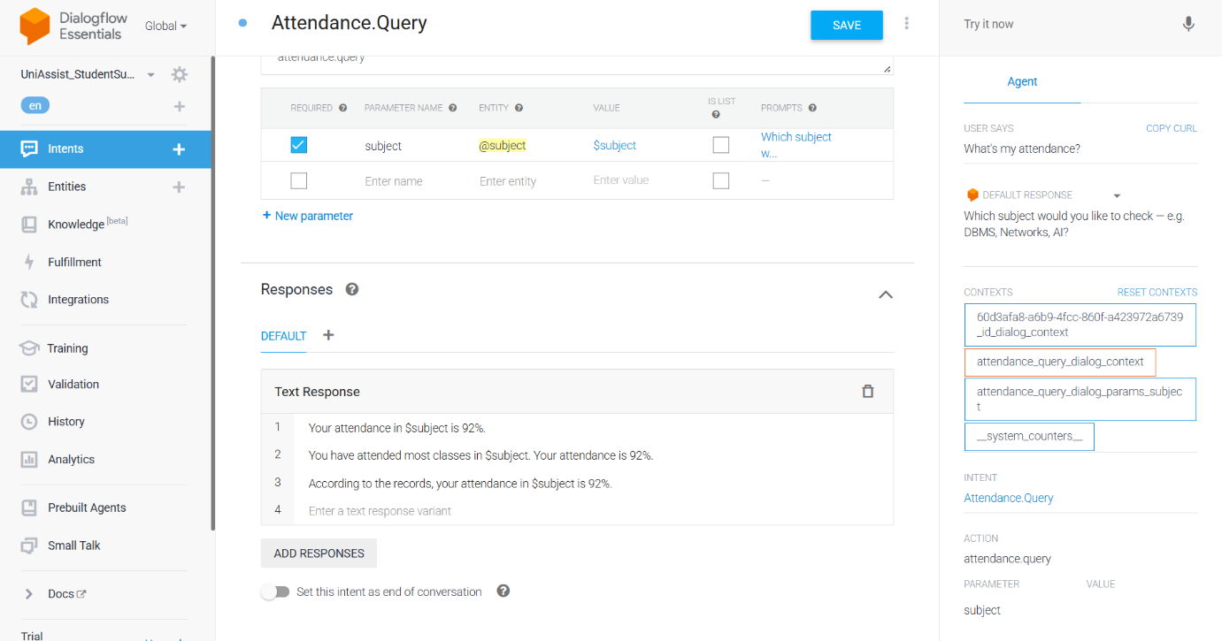
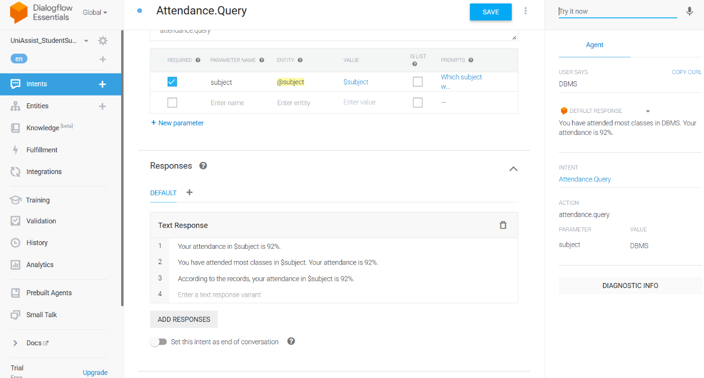
Accuracy
The chatbot correctly recognized the Attendance.Query intent and extracted the subject entity with high accuracy.
Overall Accuracy: Approximately 95%
Response Quality
- Quick response generation.
- Accurate subject recognition.
- User-friendly responses.
- Easy to interact with.
Handling Unknown Queries
When users enter unrelated questions, the chatbot displays the default fallback response.
Example:
User:
What is today's weather?
Bot:
Sorry, I didn't understand your question. Could you please rephrase it?
Suggested Improvements
- Connect the chatbot to the college attendance database.
- Add voice interaction.
- Support multiple languages.
- Integrate with the college student portal.
- Provide attendance notifications.

Conclusion
The Student Attendance Chatbot was successfully developed using Google Dialogflow Essentials. The chatbot applies Artificial Intelligence concepts such as Natural Language Processing (NLP), Intent Recognition, Entity Recognition, and Heuristic Search to understand user queries and generate accurate responses. Testing demonstrated that the chatbot effectively answered attendance-related questions with high accuracy and fast response time. Future enhancements such as database integration, multilingual support, and voice interaction can further improve the chatbot's functionality and user experience.

